 | 7.1.18 Editors - 3D Viewport - Header - Mesh - Vertex Paint mode - Paint menu
Table of content
Vertex paint Mode - Paint Menu 2
Set Vertex Colors 2
Affect Alpha 2
Smooth Vertex Colors 2
Dirty Vertex Colors 2
Last Operator Dirty Vertex Colors 2
Blur strength 2
Blur Iterations 2
Highlight Angle 2
Dirt Angle 2
Dirt only 3
Vertex Color from Weight 3
Invert 3
Levels 3
Last Operator Vertex Paint Levels 3
Offset 3
Gain 3
Hue Saturation Value 3
Last Operator Vertex Paint Hue Saturation Value 3
Hue 3
Saturation 3
Value 4
Bright / Contrast 4
Last Operator Vertex Paint Bright/Contrast 4
Brightness 4
Contrast 4

Vertex paint Mode - Paint Menu
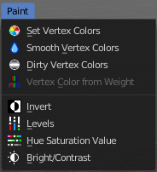
The Paint menu contains tools for vertex painting in Vertex paint mode.

Set Vertex Colors
Flood fills the vertex colors with the current vertex color value.

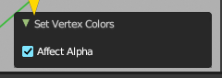
Affect Alpha
Set color to completely opaque instead of reusing existing alpha.

Smooth Vertex Colors
Smooths out the vertex colors.

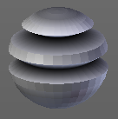
Dirty Vertex Colors
Dirty vertex colors is a special tool for aging meshes. Let's for example imagine we have a relief. Edges that are outstanding are often touched, and tends to become brighter. While areas in the inner side of a relief are not so often touched. And here the relief collects dirt too. So this areas becomes darker.
And that's what the tool simulates. It makes the outer edges brighter, and the inner edges darker. This calculation is somehow similar to Ambient Occlusion. Ambient Occlusion makes corners darker. The dirty tool makes edges brighter too. And it calculates with the vertices. Not Texel positions like AO.
You need to convert this result to a texture to use it in your texturing, as a mask for example. This conversion can be done by baking.
The tessellation of the mesh should not be too high for this operation. Since it calculates the angles of the mesh edges.

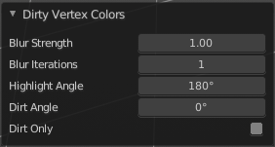
Last Operator Dirty Vertex Colors

Blur strength
How strong the result should be blurred

Blur Iterations
The number of iterations for the blur.

Highlight Angle
The angle for the bright areas. Angles higher as this value will not be recognized as an edge to highlight.

Dirt Angle
The angle for the dark areas. Angles lower as this value will not be recognized as a corner to darken.

Dirt only
Ignore the highlight areas, just calculate the dirt angles.

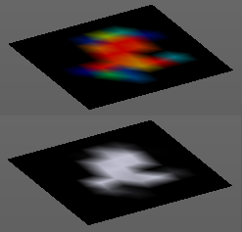
Vertex Color from Weight
This tool requires to have Weight Painting at the mesh. It converts the weight paint colors into greyscale vertex colors.

Invert
Inverts the vertex colors.

Levels
This tool allows you to level the values of the vertex painting. You adjust the settings in the last operator.

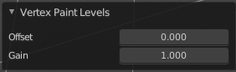
Last Operator Vertex Paint Levels

Offset
Adjust the Offset of the vertex colors.

Gain
Adjust the Gain of the vertex colors.

Hue Saturation Value
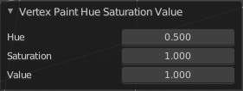
This tool allows you to adjust the hue, saturation and value values of the vertex painting. You adjust the settings in the last operator.

Last Operator Vertex Paint Hue Saturation Value

Hue
Adjust the Hue of the vertex colors.

Saturation
Adjust the Saturation of the vertex colors.

Value
Adjust the Value of the vertex colors.

Bright / Contrast
This tool allows you to adjust the brightness and the contrast of the vertex painting. You adjust the settings in the last operator.

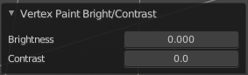
Last Operator Vertex Paint Bright/Contrast

Brightness
Adjust the brightness of the vertex colors.

Contrast
Adjust the contrast of the vertex colors.

